**Practical no 1**

**Aim:** Write a program to demonstrate bitwise operation.

**Code:**

public class Test {

public static void main(String args[]) {

int a = 60;

int b = 13;

int c = 0;

c = a & b;

System.out.println("a & b = " + c );

c = a | b;

System.out.println("a | b = " + c );

c = a ^ b;

System.out.println("a ^ b = " + c );

c = ~a;

System.out.println("~a = " + c );

c = a << 2;

System.out.println("a << 2 = " + c );

c = a >> 2;

System.out.println("a >> 2 = " + c );

c = a >>> 2; /* 15 = 0000 1111 */

System.out.println("a >>> 2 = " + c );

}

}

**Output:**

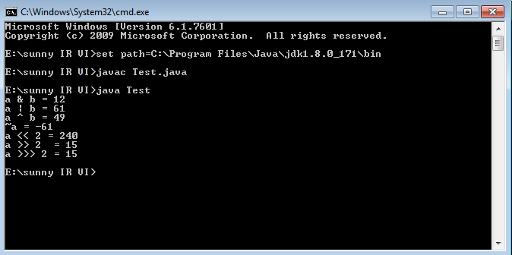

**Practical No.2**

**Aim:-** Implement Page Rank Algorithm.

**Code:-**

import java.util.*;

import java.io.*;

public class PageRank {

public int path[][] = new int[10][10];

public double pagerank[] = new double[10];

public void calc(double totalNodes){

double InitialPageRank;

double OutgoingLinks=0;

double DampingFactor = 0.85;

double TempPageRank[] = new double[10];

int ExternalNodeNumber;

int InternalNodeNumber;

int k=1; // For Traversing

int ITERATION_STEP=1;

InitialPageRank = 1/totalNodes;

System.out.printf(" Total Number of Nodes :"+totalNodes+"\t Initial PageRank of All Nodes :"+InitialPageRank+"\n");

for(k=1;k<=totalNodes;k++)

{

this.pagerank[k]=InitialPageRank;

}

System.out.printf("\n Initial PageRank Values , 0th Step \n");

for(k=1;k<=totalNodes;k++)

{

System.out.printf(" Page Rank of "+k+" is :\t"+this.pagerank[k]+"\n");

}

while(ITERATION_STEP<=2) // Iterations

{

for(k=1;k<=totalNodes;k++)

{

TempPageRank[k]=this.pagerank[k];

this.pagerank[k]=0;

}

for(InternalNodeNumber=1;InternalNodeNumber<=totalNodes;InternalNodeNumber++)

{

for(ExternalNodeNumber=1;ExternalNodeNumber<=totalNodes;ExternalNodeNumber++)

{

if(this.path[ExternalNodeNumber][InternalNodeNumber] == 1)

{

k=1;

OutgoingLinks=0; // Count the Number of Outgoing Links for each ExternalNodeNumber

while(k<=totalNodes)

{

if(this.path[ExternalNodeNumber][k] == 1 )

{

OutgoingLinks=OutgoingLinks+1; // Counter for Outgoing Links

}

k=k+1;

}

this.pagerank[InternalNodeNumber]+=TempPageRank[ExternalNodeNumber]*(1/OutgoingLinks);

}

}

}

System.out.printf("\n After "+ITERATION_STEP+"th Step \n");

for(k=1;k<=totalNodes;k++)

System.out.printf(" Page Rank of "+k+" is :\t"+this.pagerank[k]+"\n");

ITERATION_STEP = ITERATION_STEP+1;

}

for(k=1;k<=totalNodes;k++)

{

this.pagerank[k]=(1-DampingFactor)+ DampingFactor*this.pagerank[k];

}

System.out.printf("\n Final Page Rank : \n");

for(k=1;k<=totalNodes;k++)

{

System.out.printf(" Page Rank of "+k+" is :\t"+this.pagerank[k]+"\n");

}

}

public static void main(String args[])

{

int nodes,i,j,cost;

Scanner in = new Scanner(System.in);

System.out.println("Enter the Number of WebPages \n");

nodes = in.nextInt();

PageRank p = new PageRank();

System.out.println("Enter the Adjacency Matrix with 1->PATH & 0->NO PATH Between two WebPages: \n");

for(i=1;i<=nodes;i++)

for(j=1;j<=nodes;j++)

{

p.path[i][j]=in.nextInt();

if(j==i)

p.path[i][j]=0;

}

p.calc(nodes);

}

}

**Output:-**

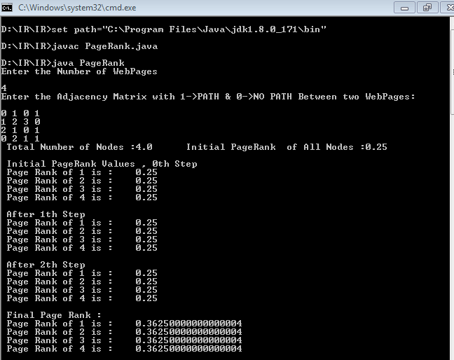

**Practical No.3**

**Aim:-** Implement Dynamic programming algorithm for computing the edit distance between

**Code:**

public class EditDistanceProblem

{

public int editDistanceRecursion(String s1,String s2,int m,int n)

{

if(m==0)

return n;

if(n==0)

return m;

if(s1.charAt(m-1)==s2.charAt(n-1))

return editDistanceRecursion(s1,s2,m-1,n-1);

return 1 + Math.min(editDistanceRecursion(s1, s2, m, n-1 ),

Math.min(editDistanceRecursion(s1, s2 , m-1 , n ),

editDistanceRecursion(s1 ,s2 , m-1 , n-1) ) );

}

public static void main(String[] args)

{

String s1 = "horizon";

String s2 = "horizontal";

EditDistanceProblem ed = new EditDistanceProblem();

System.out.println("Minimum Edit Distance - (Recursion): " +

ed.editDistanceRecursion(s1,s2,s1.length(),s2.length() ) );

}

}

**Output:**

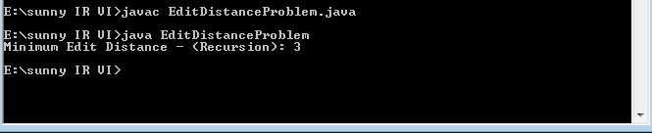

**Practical No.4**

**Aim:-** Write a program to Compute Similarity between two text documents.

**Code:-**

> install.packages('tm')

> install.packages('ggplot2')

> install.packages('textreuse')

> install.packages('devtools')

> install.packages('NLP')

> library('tm')

> require('NLP')

> library('tm')

> setwd('C:/r-corpus/')

> my.corpus<-Corpus(DirSource("C:/r-corpus"))

> my.corpus<-tm_map(my.corpus,removeWords,stopwords(kind = "english"))

> my.tdm<-TermDocumentMatrix(my.corpus)

> my.df<-as.data.frame(inspect(my.tdm))

**Output:-**

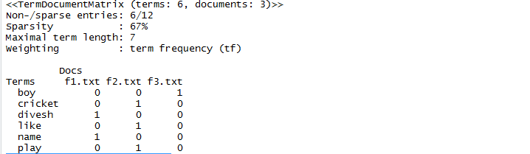

> barplot(as.matrix(my.tdm))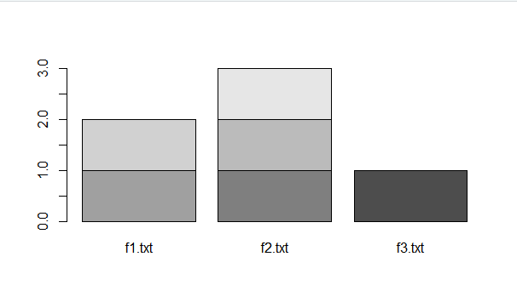

**Practical No. 5**

**Aim:** Write a map-reduce program to count the number of occurrences of each alphabetic character in the given dataset. The count for each letter should be case-insensitive (i.e., include both upper-case and lower-case versions of the letter; Ignore non-alphabetic characters).

**Steps:**

1. Install Java 8: Download Java 8 from the link: <http://www.oracle.com/technetwork/java/javase/downloads/jdk8-downloads-2133151.html>

a. Set environmental variables:

i. User variable:

• Variable: JAVA_HOME

• Value: C:\java

ii. System variable:

• Variable: PATH

• Value: C:\java\bin

b. Check on cmd, see below:

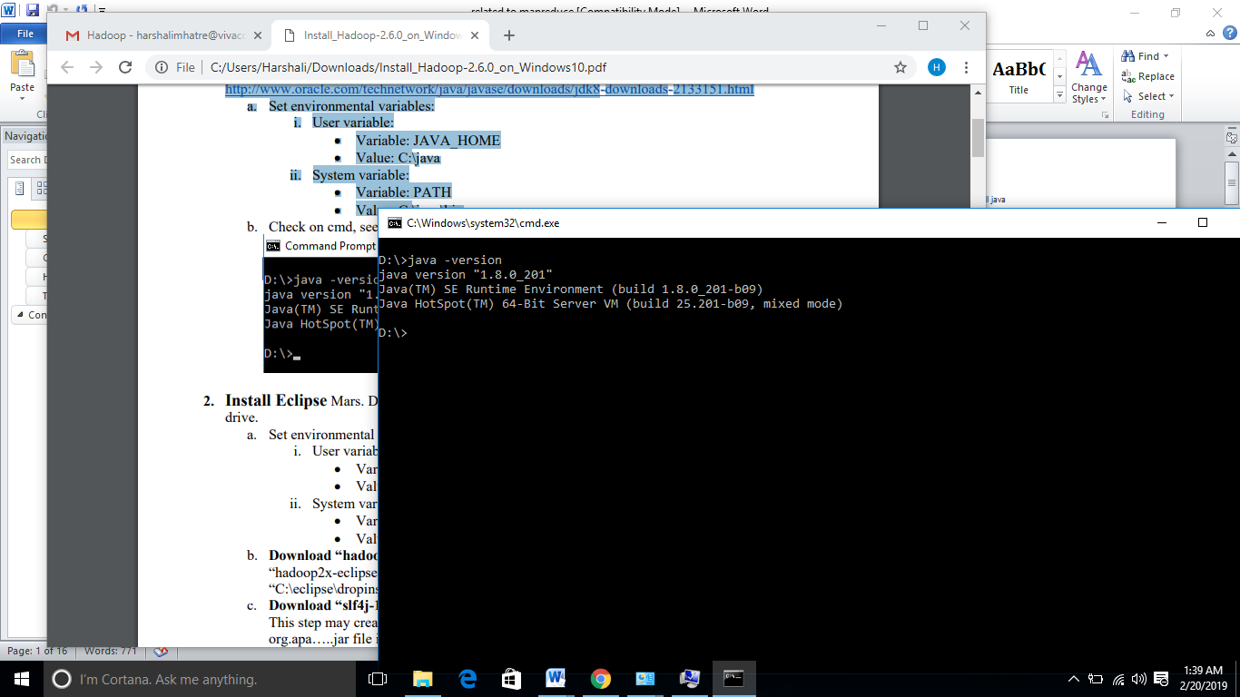

2. Install Eclipse Mars. Download it from the link: <https://eclipse.org/downloads/>

and extract it into C drive.

a. Set environmental variables:

i. User variable:

• Variable: ECLIPSE_HOME

• Value: C:\eclipse

ii. System variable:

• Variable: PATH

• Value: C:\eclipse \bin

b. Download “hadoop2x-eclipse-plugin-master.”

You will see three Jar files on the path “hadoop2x-eclipse-plugin-master\release.”

Copy these three jar files and pate them into “C:\eclipse\dropins.”

c. Download “slf4j-1.7.21.”

Copy Jar files from this folder and paste them to “C:\eclipse\plugins”.

3. Download Hadoop-2.6.x: download Hadoop 2.6.x from the link: <http://www.apache.org/dyn/closer.cgi/hadoop/common/hadoop-2.6.2/hadoop-2.6.2.tar.gz>

a. Put extracted Hadoop-2.6.x files into D drive.

Note that do not put these extracted files into C drive, where you installed your Windows.

b. Download “hadoop-common-2.6.0-bin-master” from the link:

<https://github.com/amihalik/hadoop-common-2.6.0-bin/tree/master/bin>.

You will see 11 files there.

Paste all these files into the “bin” folder of Hadoop-2.6.x.

c. Create a “data” folder inside Hadoop-2.6.x, and

also create two more folders in the “data” folder as “data” and “name.”

d. Create a folder to store temporary data during execution of a project, such as “D:\hadoop\temp.”

e. Create a log folder, such as “D:\hadoop\userlog”

f. Go to Hadoop-2.6.x /etc / Hadoop and edit four files:

i. core-site.xml

ii. hdfs-site.xml

iii. mapred.xml

iv. yarn.xml

core-site.xml

<?xml version="1.0" encoding="UTF-8"?> <?xml-stylesheet type="text/xsl" href="configuration.xsl"?> <!-- Licensed under the Apache License, Version 2.0 (the "License"); you may not use this file except in compliance with the License. You may obtain a copy of the License at

http://www.apache.org/licenses/LICENSE-2.0

Unless required by applicable law or agreed to in writing, software distributed under the License is distributed on an "AS IS" BASIS, WITHOUT WARRANTIES OR CONDITIONS OF ANY KIND, either express or implied. See the License for the specific language governing permissions and limitations under the License. See accompanying LICENSE file. -->

<!-- Put site-specific property overrides in this file. -->

<configuration> <property>

<name>hadoop.tmp.dir</name>

<value>D:\hadoop\temp</value>

</property>

<property>

<name>fs.default.name</name>

<value>hdfs://localhost:50071</value>

</property>

</configuration>

hdfs-site.xml

<?xml version="1.0" encoding="UTF-8"?>

<?xml-stylesheet type="text/xsl" href="configuration.xsl"?> <!-- Licensed under the Apache License, Version 2.0 (the "License"); you may not use this file except in compliance with the License. You may obtain a copy of the License at

http://www.apache.org/licenses/LICENSE-2.0

Unless required by applicable law or agreed to in writing, software distributed under the License is distributed on an "AS IS" BASIS, WITHOUT WARRANTIES OR CONDITIONS OF ANY KIND, either express or implied. See the License for the specific language governing permissions and limitations under the License. See accompanying LICENSE file. -->

<!-- Put site-specific property overrides in this file. -->

<configuration> <property><name>dfs.replication</name><value>1</value></property>

<property> <name>dfs.namenode.name.dir</name><value>/hadoop2.6.2/data/name</value><final>true</final></property>

<property><name>dfs.datanode.data.dir</name><value>/hadoop2.6.2/data/data</value><final>true</final> </property> </configuration>

mapred.xml

<?xml version="1.0"?> <configuration <property>

<name>mapreduce.framework.name</name>

<value>yarn</value>

</property>

<property>

<name>mapred.job.tracker</name>

<value>localhost:9001</value>

</property>

<property>

<name>mapreduce.application.classpath</name>

<value>/hadoop-2.6.2/share/hadoop/mapreduce/*,

/hadoop-2.6.2/share/hadoop/mapreduce/lib/*,

/hadoop-2.6.2/share/hadoop/common/*,

/hadoop-2.6.2/share/hadoop/common/lib/*,

/hadoop-2.6.2/share/hadoop/yarn/*,

/hadoop-2.6.2/share/hadoop/yarn/lib/*,

/hadoop-2.6.2/share/hadoop/hdfs/*,

/hadoop-2.6.2/share/hadoop/hdfs/lib/*,

</value>

</property></configuration>

yarn-site.xml

<?xml version="1.0"?> <!-- Licensed under the Apache License, Version 2.0 (the "License"); you may not use this file except in compliance with the License. You may obtain a copy of the License at

http://www.apache.org/licenses/LICENSE-2.0

Unless required by applicable law or agreed to in writing, software distributed under the License is distributed on an "AS IS" BASIS, WITHOUT WARRANTIES OR CONDITIONS OF ANY KIND, either express or implied. See the License for the specific language governing permissions and limitations under the License. See accompanying LICENSE file. -->

<configuration> <property>

<name>yarn.nodemanager.aux-services</name>

<value>mapreduce_shuffle</value>

</property>

<property>

<name>yarn.nodemanager.aux-services.mapreduce.shuffle.class</name>

<value>org.apache.hadoop.mapred.ShuffleHandler</value>

</property>

<property>

<name>yarn.nodemanager.log-dirs</name>

<value>D:\hadoop\userlog</value><final>true</final>

</property>

<property><name>yarn.nodemanager.local-dirs</name><value>D:\hadoop\temp\nm-localdir</value></property>

<property>

<name>yarn.nodemanager.delete.debug-delay-sec</name>

<value>600</value></property>

<property><name>yarn.application.classpath</name>

<value>/hadoop-2.6.2/,/hadoop-2.6.2/share/hadoop/common/*,/hadoop2.6.2/share/hadoop/common/lib/*,/hadoop-2.6.2/share/hadoop/hdfs/*,/hadoop2.6.2/share/hadoop/hdfs/lib/*,/hadoop-2.6.2/share/hadoop/mapreduce/*,/hadoop2.6.2/share/hadoop/mapreduce/lib/*,/hadoop-2.6.2/share/hadoop/yarn/*,/hadoop2.6.2/share/hadoop/yarn/lib/*</value>

</property></configuration>

g. Go to the location: “Hadoop-2.6.0/etc/hadoop,” and edit “hadoop-env.cmd” by writing set JAVA_HOME= C:\Progra~1\Java\jdk1.8.0_201

h. Set environmental variables:

Do: My computer → Properties → Advance system settings → Advanced → Environmental variables

1. User variables:

* Variable: HADOOP_HOME
* Value: D:\hadoop-2.6.0

1. System variable

* Variable: Path
* 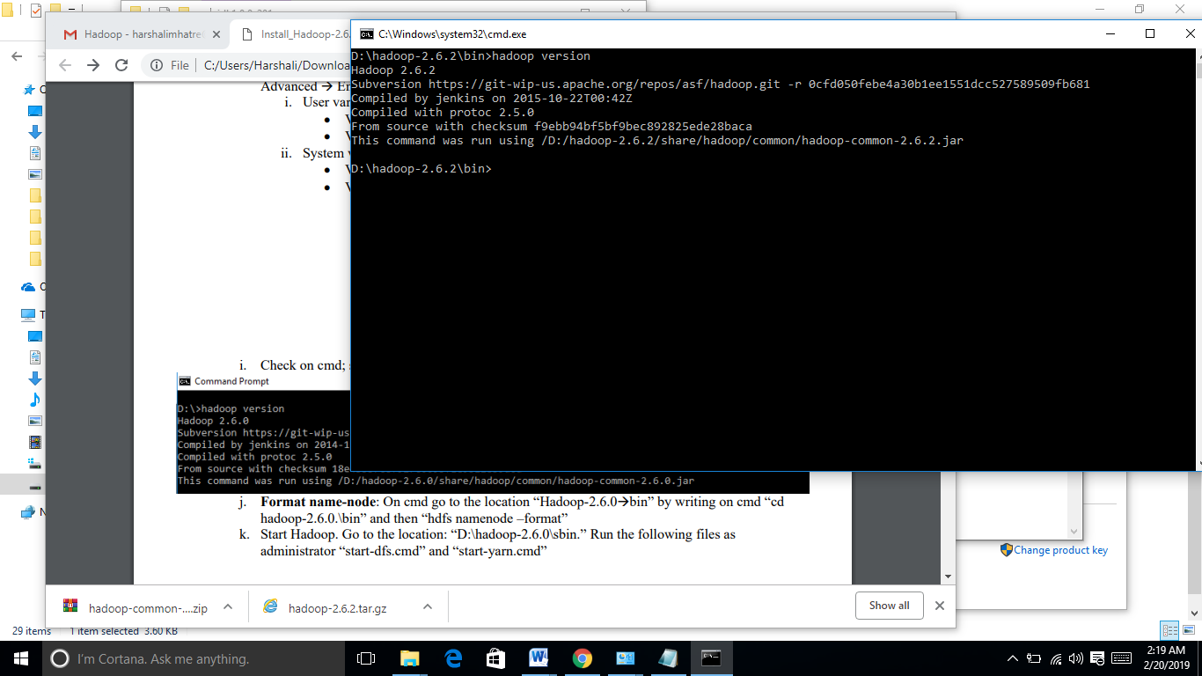 Value: D:\hadoop-2.6.2\bin D:\hadoop-2.6.2\sbin D:\hadoop-2.6.2\share\hadoop\common\* D:\hadoop-2.6.2\share\hadoop\hdfs D:\hadoop-2.6.2\share\hadoop\hdfs\lib\* D:\hadoop-2.6.2\share\hadoop\hdfs\* D:\hadoop-2.6.2\share\hadoop\yarn\lib\* D:\hadoop-2.6.2\share\hadoop\yarn\* D:\hadoop-2.6.2\share\hadoop\mapreduce\lib\* D:\hadoop-2.6.2\share\hadoop\mapreduce\* D:\hadoop-2.6.2\share\hadoop\common\lib\*

i. Check on cmd; see below

j. Format name-node:

On cmd go to the location “Hadoop-2.6.2/bin” by writing on cmd “cd hadoop-2.6.2.\bin” and then “hdfs namenode –format”

k. Start Hadoop. Go to the location: “D:\hadoop-2.6.0\sbin.”

Run the following files as administrator “start-all.cmd”

------------------------------------------------------------------------------------------------  
How to create a new MapReduce project in Eclipse

1. Open Ellipse

2. Click File - New Project - Java project

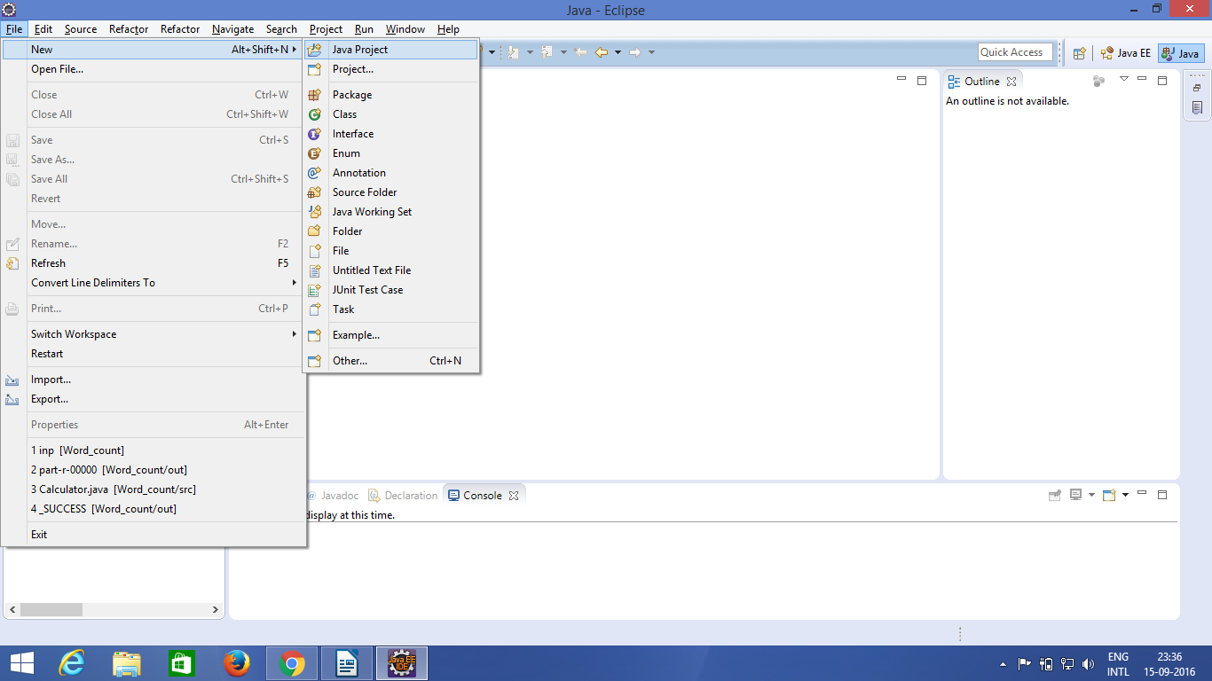

Hereafter clicking on the New Java project, it will ask for the project name as shown in the below screen shot. Give a project name. Here we have given the project name as W**ord_count**.

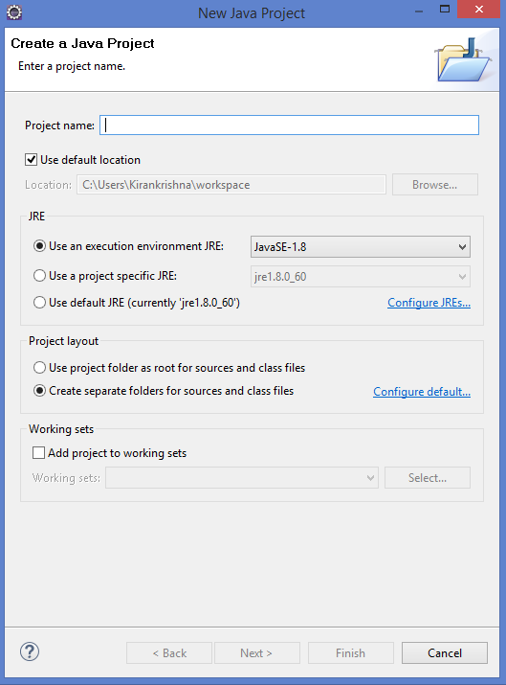

Now after giving the project name, a project will be created with the given name. Click on the project and inside the project, you will find a directory called **src**. Right click and create new class as shown in the below screen shot.

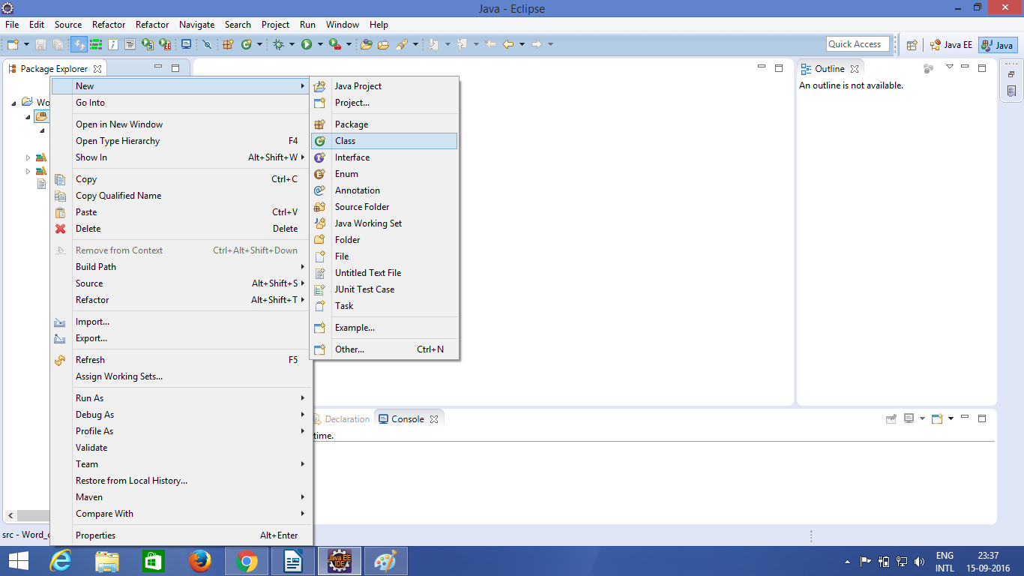

Now you will be prompted with another screen to provide the class name as shown in the below screen shot.

Here, give the class name of your choice. We have given the name as **WordCount**. Inside the **src,**a file with name **WordCount.java**has been created. Click on the file and write the MapReduce code for the word count program

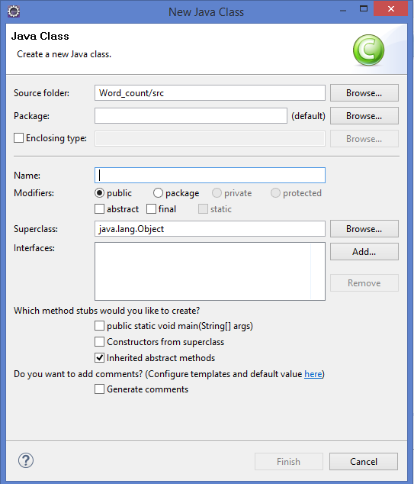

**Source Code:**

import java.io.IOException;

import java.util.StringTokenizer;

import org.apache.hadoop.conf.Configuration;

import org.apache.hadoop.fs.Path;

import org.apache.hadoop.io.IntWritable;

import org.apache.hadoop.io.Text;

import org.apache.hadoop.mapreduce.Job;

import org.apache.hadoop.mapreduce.Mapper;

import org.apache.hadoop.mapreduce.Reducer;

import org.apache.hadoop.mapreduce.lib.input.FileInputFormat;

import org.apache.hadoop.mapreduce.lib.output.FileOutputFormat;

public class WordCount {

public static class TokenizerMapper

extends Mapper<Object, Text, Text, IntWritable>{

private final static IntWritable one = new IntWritable(1);

private Text word = new Text();

public void map(Object key, Text value, Context context

) throws IOException, InterruptedException {

StringTokenizer itr = new StringTokenizer(value.toString());

while (itr.hasMoreTokens()) {

word.set(itr.nextToken());

context.write(word, one);

}

}

}

public static class IntSumReducer

extends Reducer<Text,IntWritable,Text,IntWritable> {

private IntWritable result = new IntWritable();

public void reduce(Text key, Iterable<IntWritable> values,

Context context

) throws IOException, InterruptedException {

int sum = 0;

for (IntWritable val : values) {

sum += val.get();

}

result.set(sum);

context.write(key, result);

}

}

public static void main(String[] args) throws Exception {

Configuration conf = new Configuration();

Job job = Job.getInstance(conf, "word count");

job.setJarByClass(WordCount.class);

job.setMapperClass(TokenizerMapper.class);

job.setCombinerClass(IntSumReducer.class);

job.setReducerClass(IntSumReducer.class);

job.setOutputKeyClass(Text.class);

job.setOutputValueClass(IntWritable.class);

FileInputFormat.addInputPath(job, new Path(args[0]));

FileOutputFormat.setOutputPath(job, new Path(args[1]));

System.exit(job.waitForCompletion(true) ? 0 : 1);

}

}

After copying the code save the file. Now you need to add a few dependency files for running this program in Windows.

First, we need to add the jar files that are present in **hadoop-2.6.0/share/hadoop**directory. For that **Righ click on src–>Build path–>Configure build path**as shown in the below screen shot.

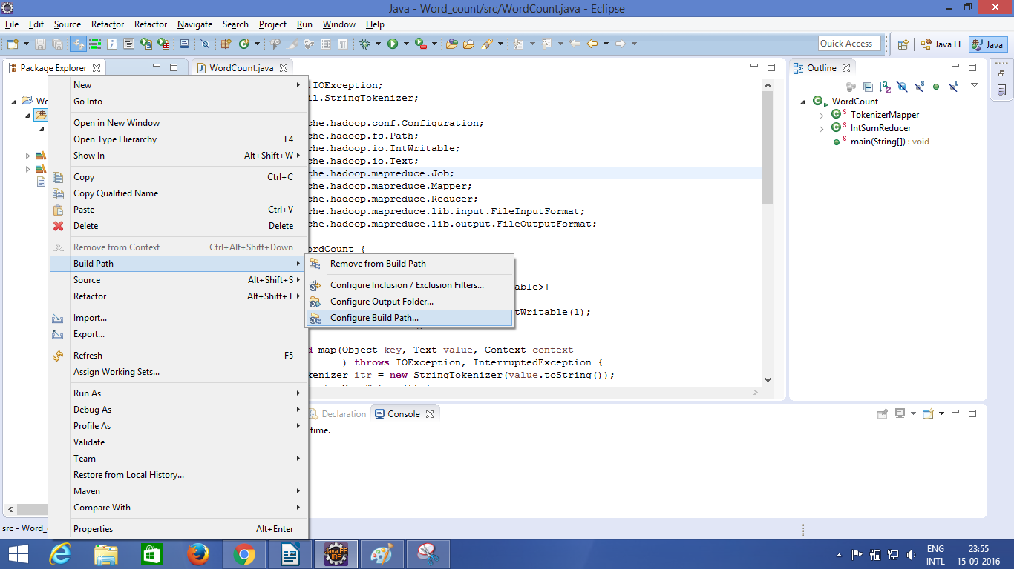

In the **Build Path**select the **Libraries**tab and click on **Add External Jars**.

Now browse the path where the **Hadoop-2.6.0**extracted folder is present.

Copy all the Jar files from the locations “D:\hadoop-2.6.0\”

a. \share\hadoop\common\lib

b. \share\hadoop\mapreduce

c. \share\hadoop\mapreduce\lib

d. share\hadoop\yarn

e. \share\hadoop\yarn\lib

Open the **hadoop-2.6.0/share/hadoop/hdfs/lib**

folder and add the **commons-io-2.4.jar**file

Open the **hadoop-2.6.0/share/hadoop/tools/lib**

and add the **hadoop-auth-2.6.0.jar**file

Create bin folder under hadoop-2.6.2/bin

And add **winutils**files(lib and exe)

That’s it all the set up required for running your Hadoop application in Windows. Make sure that your input file is ready.

Here we have created our input file in the project directory itself with the name **input**as shown in the below screen shot.

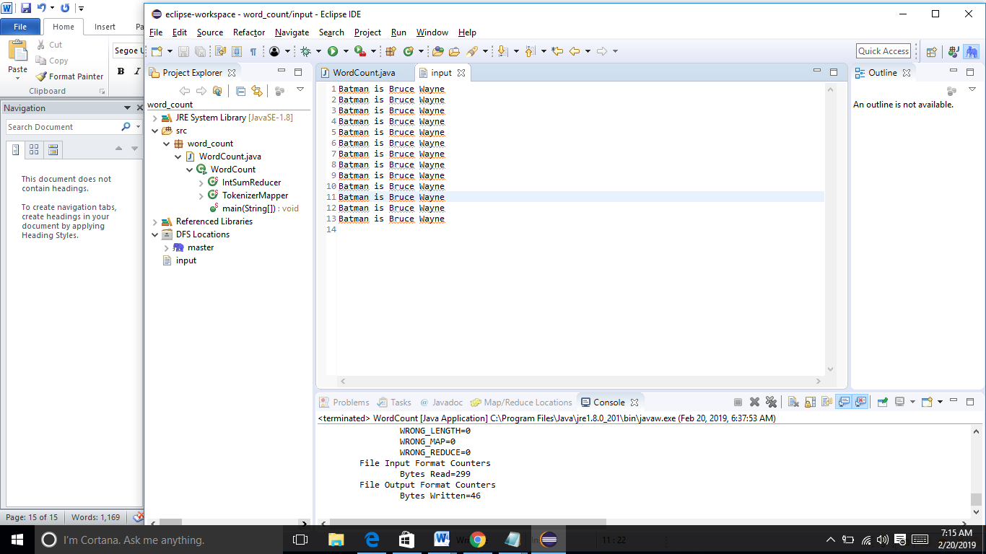

For giving the input and output file paths, **Right click on the main class–>Run As–>Run configurations**

as shown in the below screen shot.

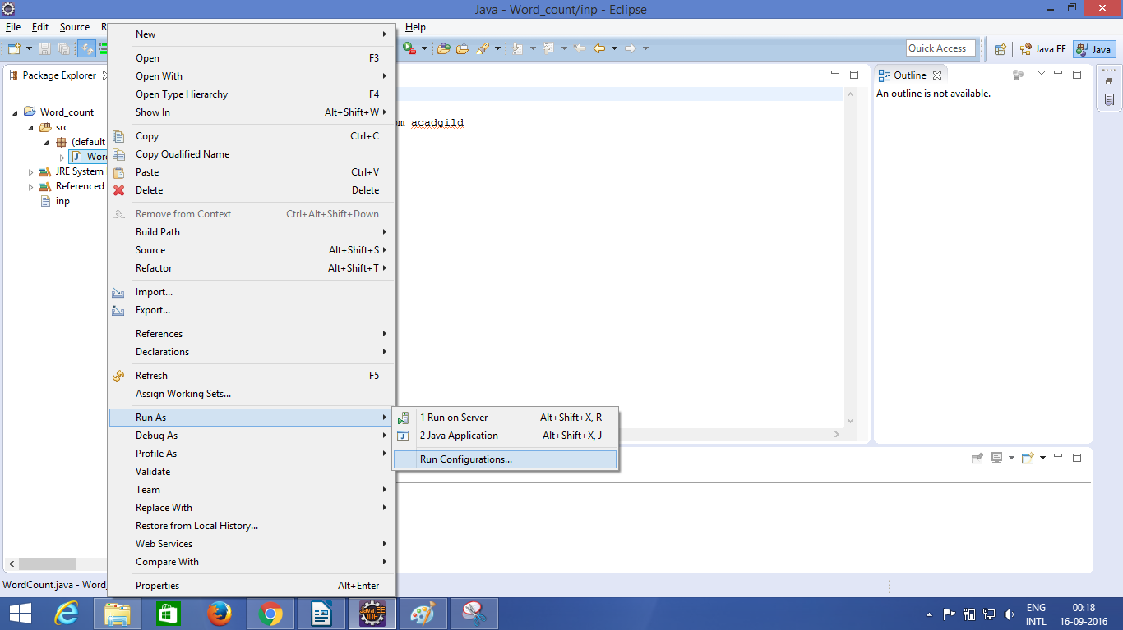

In the **main**select the project name and the class name of the program as shown in the below screen shot.

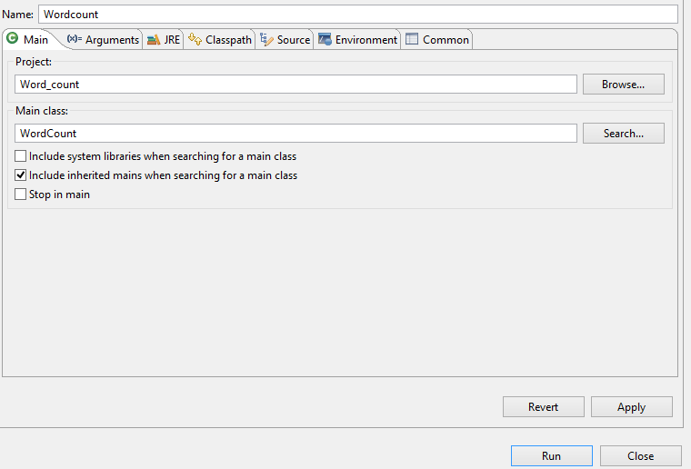

Now move into the **Arguments**tab and provide the **input file path**and the **output file path**as shown in the below screen shot.

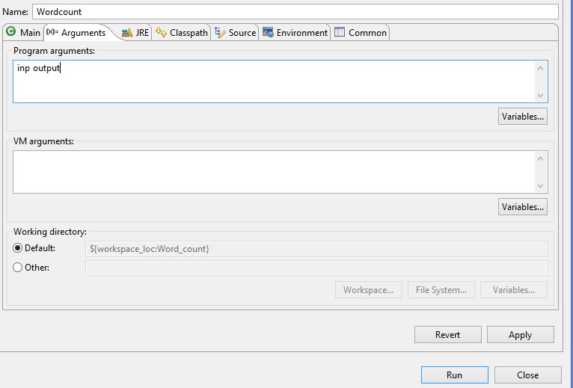

Since we have our input file inside the project directory itself, we have just given **inp**as input file path and then a **tabspace.**We have given the **output file path**as just **output.**It will create the output directory inside the project directory itself.

Now click on Run. You will see the Eclipse console running

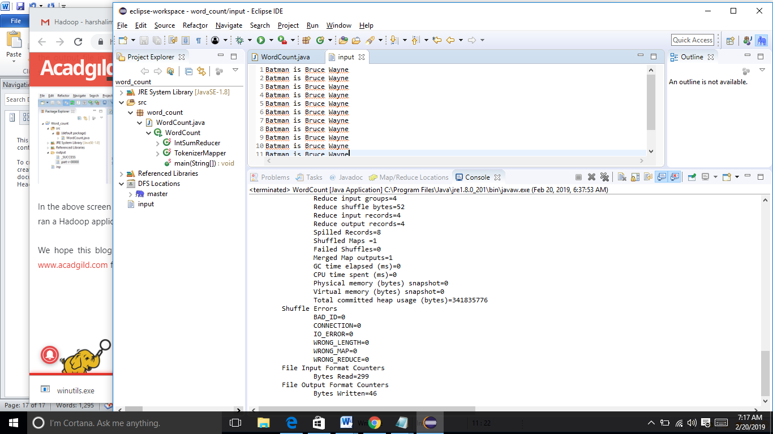

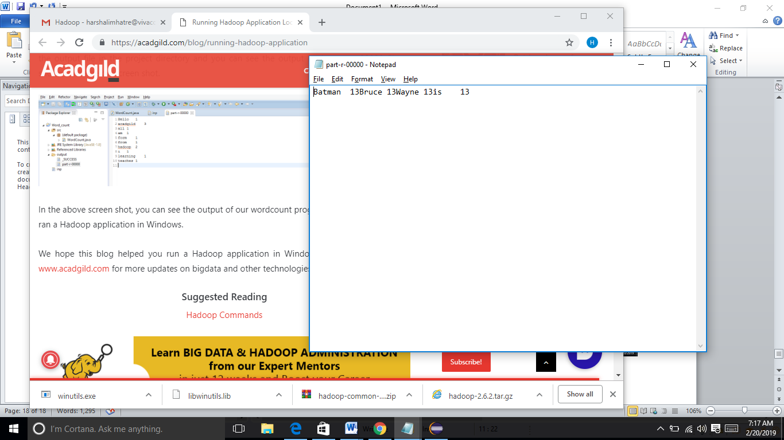

**Practical No.6**

**Aim:-** Write a program to Compute Similarity between two text documents.

**Code:-**

**LuceneConstants.java**

package com.tutorialspoint.lucene;

public class LuceneConstants {

public static final String CONTENTS = "contents";

public static final String FILE_NAME = "filename";

public static final String FILE_PATH = "filepath";

public static final int MAX_SEARCH = 10;

}

### TextFileFilter.java:-

### package com.tutorialspoint.lucene;

### import java.io.File;

### import java.io.FileFilter;

### public class TextFileFilter implements FileFilter {

### @Override

### public boolean accept(File pathname) {

### return pathname.getName().toLowerCase().endsWith(".txt");

### }

### }

### Indexer.java:-

### package com.tutorialspoint.lucene;

### import java.io.File;

### import java.io.FileFilter;

### import java.io.FileReader;

### import java.io.IOException;

### import org.apache.lucene.analysis.standard.StandardAnalyzer;

### import org.apache.lucene.document.Document;

### import org.apache.lucene.document.Field;

### import org.apache.lucene.index.CorruptIndexException;

### import org.apache.lucene.index.IndexWriter;

### import org.apache.lucene.store.Directory;

### import org.apache.lucene.store.FSDirectory;

### import org.apache.lucene.util.Version;

### public class Indexer {

### private IndexWriter writer;

### public Indexer(String indexDirectoryPath) throws IOException {

### Directory indexDirectory =

### FSDirectory.open(new File(indexDirectoryPath));

### writer = new IndexWriter(indexDirectory,

### new StandardAnalyzer(Version.LUCENE_36),true,

### IndexWriter.MaxFieldLength.UNLIMITED);

### }

### public void close() throws CorruptIndexException, IOException {

### writer.close();

### }

### private Document getDocument(File file) throws IOException {

### Document document = new Document();

### Field contentField = new Field(LuceneConstants.CONTENTS, new FileReader(file));

### Field fileNameField = new Field(LuceneConstants.FILE_NAME,

### file.getName(),Field.Store.YES,Field.Index.NOT_ANALYZED);

### Field filePathField = new Field(LuceneConstants.FILE_PATH,

### file.getCanonicalPath(),Field.Store.YES,Field.Index.NOT_ANALYZED);

### document.add(contentField);

### document.add(fileNameField);

### document.add(filePathField);

### return document;

### }

### private void indexFile(File file) throws IOException {

### System.out.println("Indexing "+file.getCanonicalPath());

### Document document = getDocument(file);

### writer.addDocument(document);

### }

### public int createIndex(String dataDirPath, FileFilter filter)

### throws IOException {

### File[] files = new File(dataDirPath).listFiles();

### for (File file : files) {

### if(!file.isDirectory()

### && !file.isHidden()

### && file.exists()

### && file.canRead()

### && filter.accept(file)

### ){

### indexFile(file);

### }

### }

### return writer.numDocs();

### }

### }

### Searcher.java:-

**package** com.tutorialspoint.lucene;

**import** java.io.File;

**import** java.io.IOException;

**import** org.apache.lucene.analysis.standard.StandardAnalyzer;

**import** org.apache.lucene.document.Document;

**import** org.apache.lucene.index.CorruptIndexException;

**import** org.apache.lucene.queryParser.ParseException;

**import** org.apache.lucene.queryParser.QueryParser;

**import** org.apache.lucene.search.IndexSearcher;

**import** org.apache.lucene.search.Query;

**import** org.apache.lucene.search.ScoreDoc;

**import** org.apache.lucene.search.TopDocs;

**import** org.apache.lucene.store.Directory;

**import** org.apache.lucene.store.FSDirectory;

**import** org.apache.lucene.util.Version;

**public** **class** Searcher {

IndexSearcher indexSearcher;

QueryParser queryParser;

Query query;

**public** Searcher(String indexDirectoryPath)

**throws** IOException {

Directory indexDirectory =

FSDirectory.*open*(**new** File(indexDirectoryPath));

indexSearcher = **new** ~~IndexSearcher~~(indexDirectory);

queryParser = **new** QueryParser(Version.***LUCENE_36***,

LuceneConstants.***CONTENTS***,

**new** StandardAnalyzer(Version.***LUCENE_36***));

}

**public** TopDocs search( String searchQuery)

**throws** IOException, ParseException {

query = queryParser.parse(searchQuery);

**return** indexSearcher.search(query, LuceneConstants.***MAX_SEARCH***);

}

**public** Document getDocument(ScoreDoc scoreDoc)

**throws** CorruptIndexException, IOException {

**return** indexSearcher.doc(scoreDoc.doc);

}

**public** **void** close() **throws** IOException {

indexSearcher.close();

}

### }

### LuceneTester.java:-

**package** com.tutorialspoint.lucene;

**import** java.io.IOException;

**import** org.apache.lucene.document.Document;

**import** org.apache.lucene.queryParser.ParseException;

**import** org.apache.lucene.search.ScoreDoc;

**import** org.apache.lucene.search.TopDocs;

**public** **class** LuceneTester {

String indexDir = "D:\\Lucene\\Index";

String dataDir = "D:\\Lucene\\Data";

Indexer indexer;

Searcher searcher;

**public** **static** **void** main(String[] args) {

LuceneTester tester;

**try** {

tester = **new** LuceneTester();

tester.createIndex();

tester.search("Mohan");

} **catch** (IOException e) {

e.printStackTrace();

} **catch** (ParseException e) {

e.printStackTrace();

}

}

**private** **void** createIndex() **throws** IOException {

indexer = **new** Indexer(indexDir);

**int** numIndexed;

**long** startTime = System.*currentTimeMillis*();

numIndexed = indexer.createIndex(dataDir, **new** TextFileFilter());

**long** endTime = System.*currentTimeMillis*();

indexer.close();

System.***out***.println(numIndexed+" File indexed, time taken: "

+(endTime-startTime)+" ms");

}

**private** **void** search(String searchQuery) **throws** IOException, ParseException {

searcher = **new** Searcher(indexDir);

**long** startTime = System.*currentTimeMillis*();

TopDocs hits = searcher.search(searchQuery);

**long** endTime = System.*currentTimeMillis*();

System.***out***.println(hits.totalHits +

" documents found. Time :" + (endTime - startTime));

**for**(ScoreDoc scoreDoc : hits.scoreDocs) {

Document doc = searcher.getDocument(scoreDoc);

System.***out***.println("File: "

+ doc.get(LuceneConstants.***FILE_PATH***));

}

searcher.close();

}

}

**Output:-**

### 

**Practical No.9**

**Aim:** Write a program to implement simple web crawler.

**Code**:

import java.net.*;

import java.io.*;

public class Crawler{

public static void main(String[] args) throws Exception{

String urls[] = new String[1000];

String url = "https://www.cricbuzz.com/live-cricket-scores/20307/aus-vs-ind-3rd-odi-india-tour-of-australia-2018-19";

int i=0,j=0,tmp=0,total=0, MAX = 1000;

int start=0, end=0;

String webpage = Web.getWeb(url);

end = webpage.indexOf("<body");

for(i=total;i<MAX; i++, total++){

start = webpage.indexOf("http://", end);

if(start == -1){

start = 0;

end = 0;

try{

webpage = Web.getWeb(urls[j++]);

}catch(Exception e){

System.out.println("******************");

System.out.println(urls[j-1]);

System.out.println("Exception caught \n"+e);

}

/*logic to fetch urls out of body of webpage only */

end = webpage.indexOf("<body");

if(end == -1){

end = start = 0;

continue;

}

}

end = webpage.indexOf("\"", start);

tmp = webpage.indexOf("'", start);

if(tmp < end && tmp != -1){

end = tmp;

}

url = webpage.substring(start, end);

urls[i] = url;

System.out.println(urls[i]);

}

System.out.println("Total URLS Fetched are " + total);

}

}

/*This class contains a static function which will fetch the webpage

of the given url and return as a string */

class Web{

public static String getWeb(String address)throws Exception{

String webpage = "";

String inputLine = "";

URL url = new URL(address);

BufferedReader in = new BufferedReader(

new InputStreamReader(url.openStream()));

while ((inputLine = in.readLine()) != null)

webpage += inputLine;

in.close();

return webpage;

}

}

**Output:**

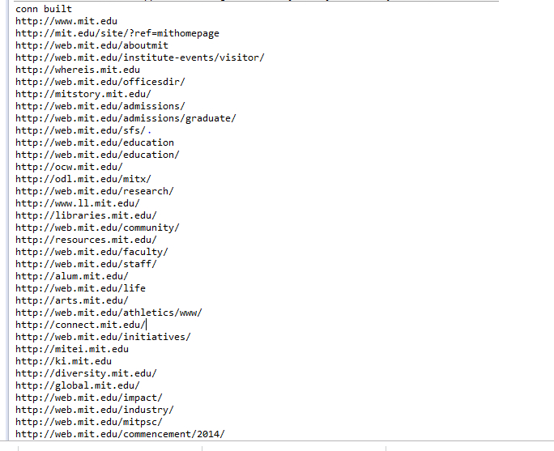

**Practical No.10**

**Aim:-** Write a program to parse XML text, generate Web graph and compute topic specific page rank.

**emp.xml:-**

<?xml version="1.0" encoding="UTF-8"?>

<employee>

<fname>Divesh</fname>

<lname>Saurabh</lname>

<home>Thane</home>

<expertise name="SQl"/>

<expertise name="Python"/>

<expertise name="Testing"/>

<expertise name="Business"/>

</employee>

**emp.py:-**

import xml.dom.minidom

def main():

doc=xml.dom.minidom.parse("emp.xml");

print(doc.nodeName)

print(doc.firstChild.tagName)

if __name__=="__main__":

main()



**emp1.py:-**

import xml.dom.minidom

def main():

doc = xml.dom.minidom.parse("emp.xml");

print (doc.nodeName)

print (doc.firstChild.tagName)

expertise = doc.getElementsByTagName("expertise")

print ("%d expertise:" % expertise.length)

for skill in expertise:

print (skill.getAttribute("name"))

newexpertise = doc.createElement("expertise")

newexpertise.setAttribute("name", "BigData")

doc.firstChild.appendChild(newexpertise)

print (" ")

expertise = doc.getElementsByTagName("expertise")

print ("%d expertise:" % expertise.length)

for skill in expertise:

print (skill.getAttribute("name"))

if __name__ == "__main__":

main();

**Output:**

